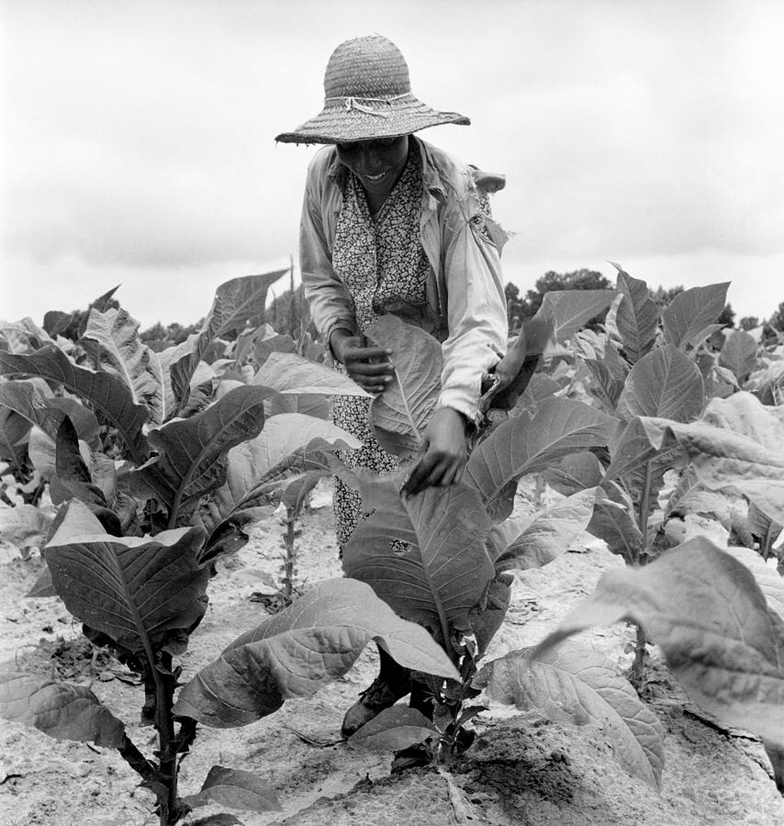  We Need You!  - The Indigenous Family Farmers Aboriginal Alliance is a farm project that will provide fresh food to the community. We are tired of not having healthy affordable food options easily accessible to our community, making it increasingly difficult to maintain a healthy level of fruits and vegetables in our diets. We are having light food and a information session on who we are, what we do and how you can be involved.  Location: Destiny International Church  7061 Lemington Ave, Pittsburgh,P.A., 15206  When: November, 25,2018  Time: 1:30pm to 3:30pm | R.S.V.P. At 4122181606  Bianca Keys  R.S.V.P. At 4122181606  Bianca Keys  R.S.V.P. At 4122181606  Bianca Keys  R.S.V.P. At 4122181606  Bianca Keys  R.S.V.P. At 4122181606  Bianca Keys  R.S.V.P. At 4122181606  Bianca Keys  R.S.V.P. At 4122181606  Bianca Keys  R.S.V.P. At 4122181606  Bianca Keys  R.S.V.P. At 4122181606  Bianca Keys  R.S.V.P. At 4122181606  Bianca Keys  R.S.V.P. At 4122181606  Bianca Keys  Item  Bianca Keys  Item  Bianca Keys  Item  Bianca Keys

